**Practical 1: Working On Google Drive To Make Spreadsheets And Notes.**

**For Sheets:**

Step 1: Open chrome click on top left side option.

Step 2: Click on sheets option.

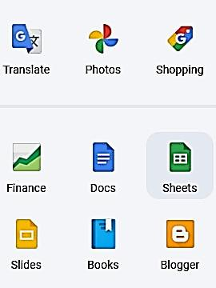 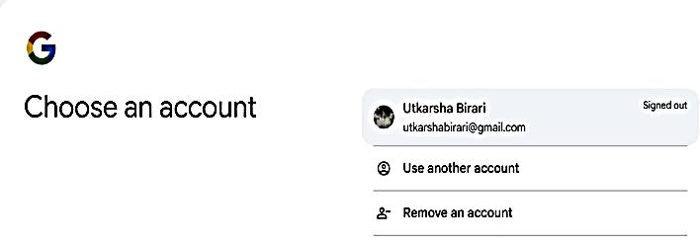

Step 3: Enter your mail id and password for sign in.

Step 4: Below window open click on blank spreadsheet option.

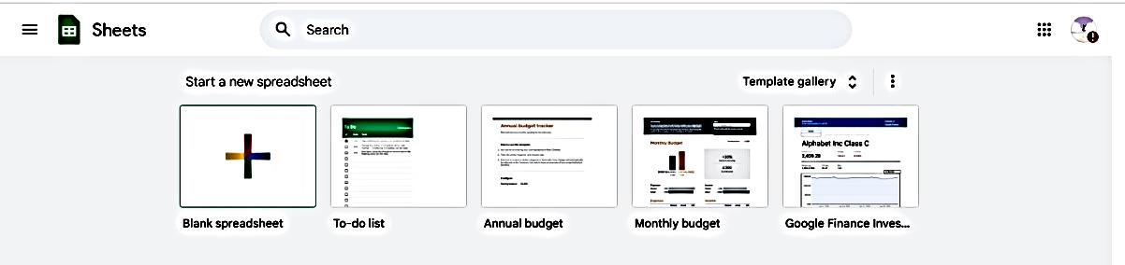

Step 5: New window will open click on untitled spreadsheet and give any7 suitable name to your sheet.

Step 6: Write your data on this sheet and use other options to modify it size fonts color etc.

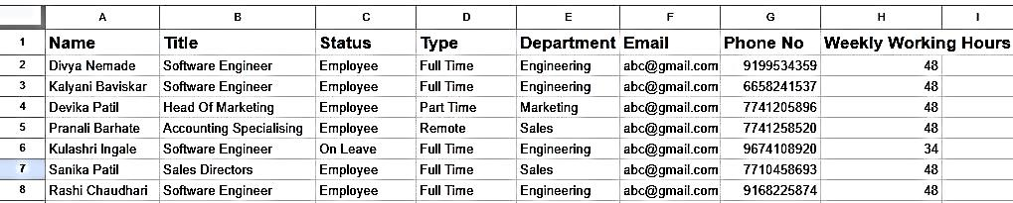

**For Notes:**

Step 1: Click on Docs option.

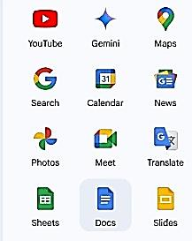

Step 2: Click on blank document and edit the name of your notes.

Step 3: Write your notes. Your notes saved.

